1. **Triangles Data** The **TRIANGLES** table is described as follows:



|  |  |  |  |
| --- | --- | --- | --- |
| **Triangle** | **Side_A** | **Side_B** | **Side_C** |
| 1 | 20 | 20 | 23 |
| 2 | 20 | 20 | 20 |
| 3 | 20 | 21 | 22 |
| 4 | 13 | 14 | 30 |

**Questions :**

* + 1. Write a query to create the **TRIANGLES** table. (**Note:-** In answer, submit all the table creation queries.)

**ANS**

**:**

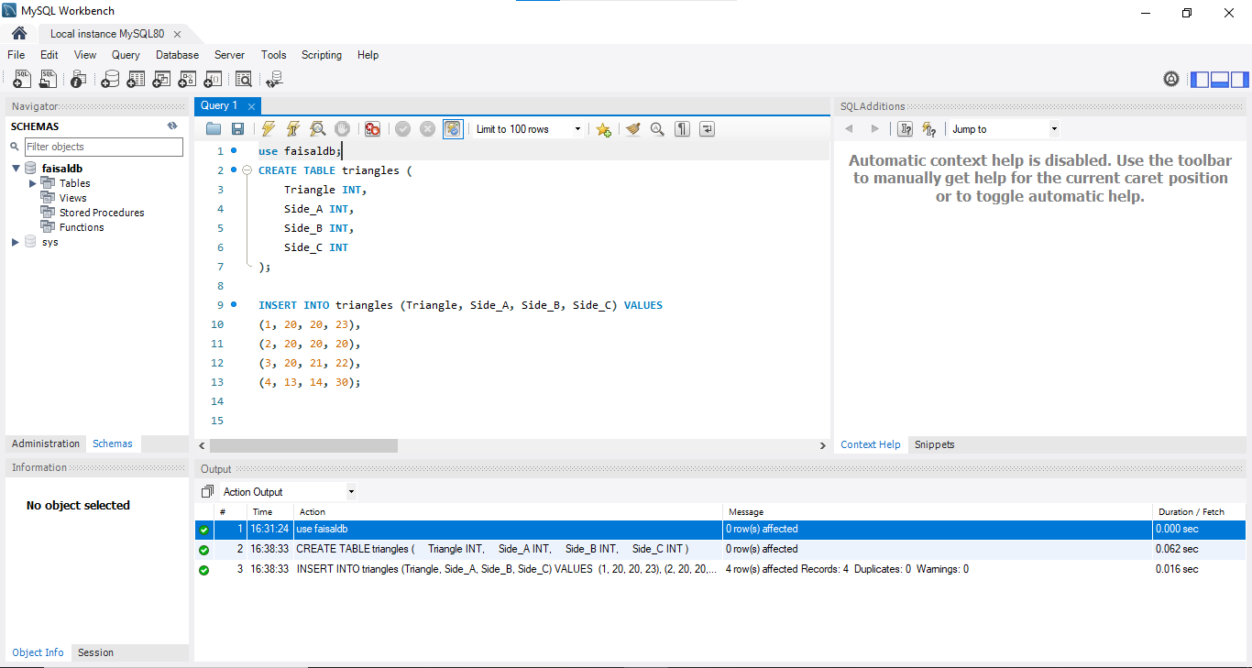

* + 1. Write queries to get output as per required :

* + 1. Write a query to obtain the sum of side_A of all triangles.

**ANS :**

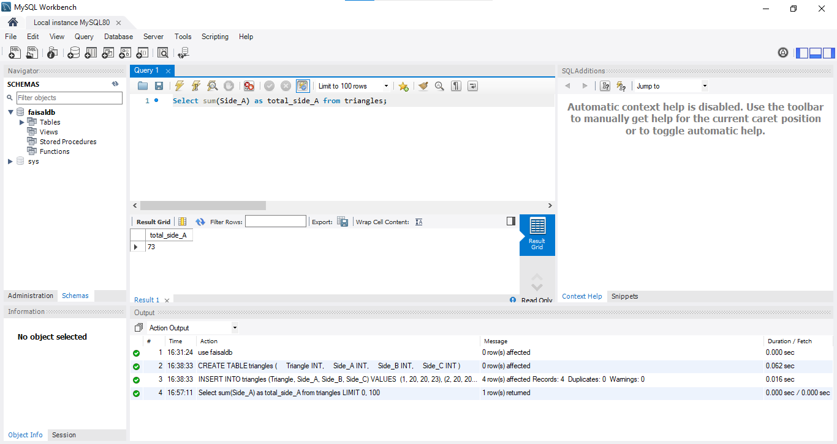

* + 1. Write a query to obtain an equilateral triangle from the table.

**ANS :**

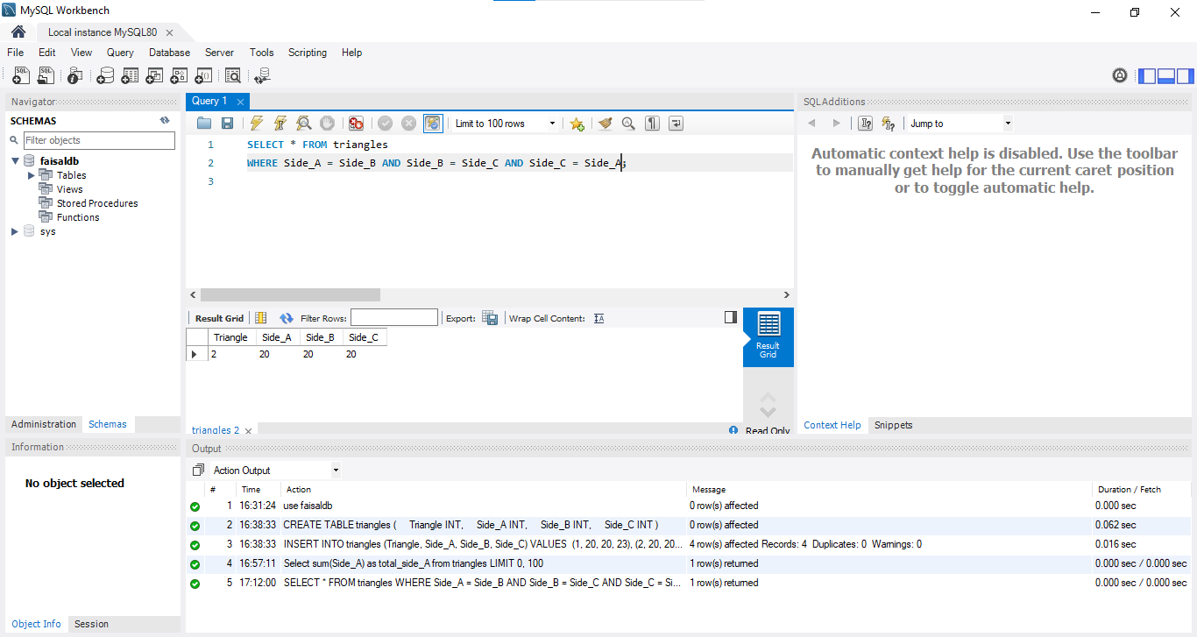

* + 1. Write a query to obtain an isosceles triangle from the table.

**ANS :**

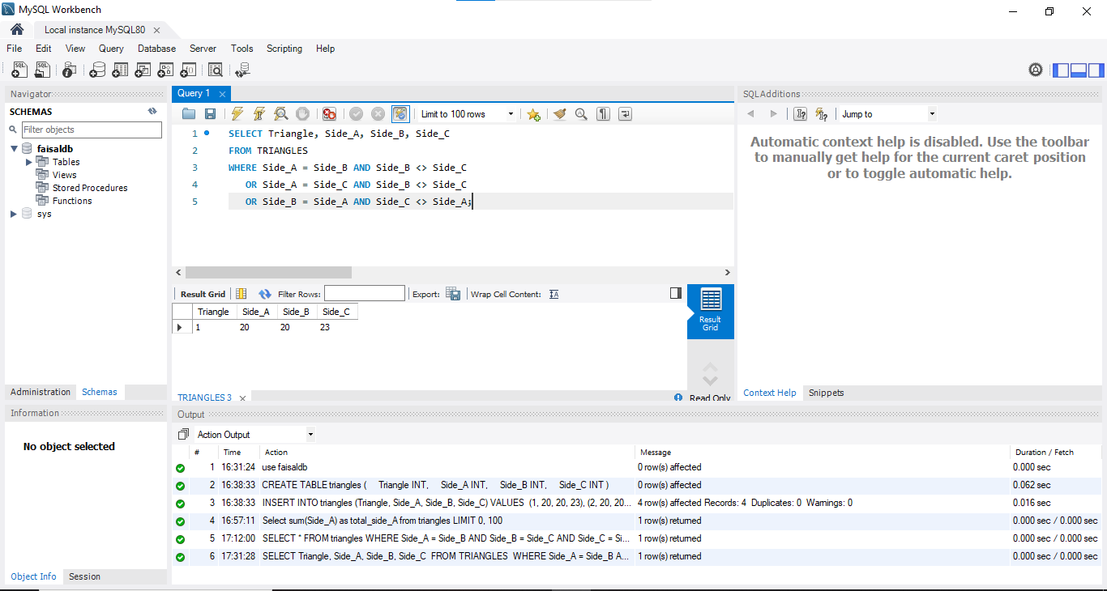

* + 1. Find the no. of triangles in the table.

**ANS :**

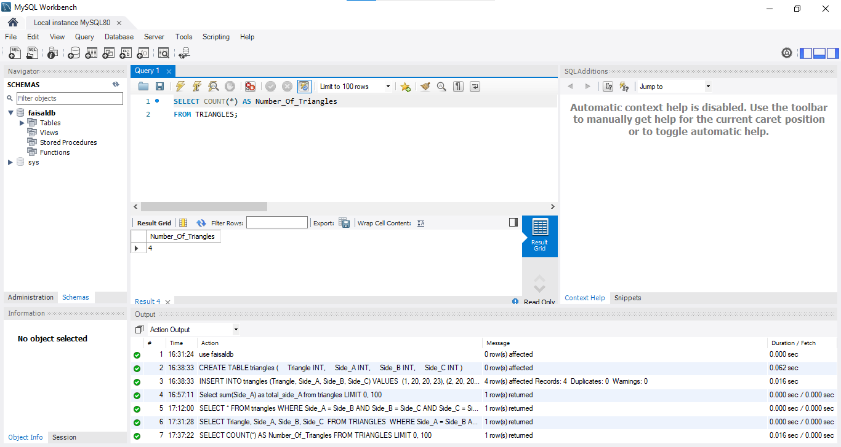

* + 1. Find the length of side_B of Triangle 3.

**ANS :**

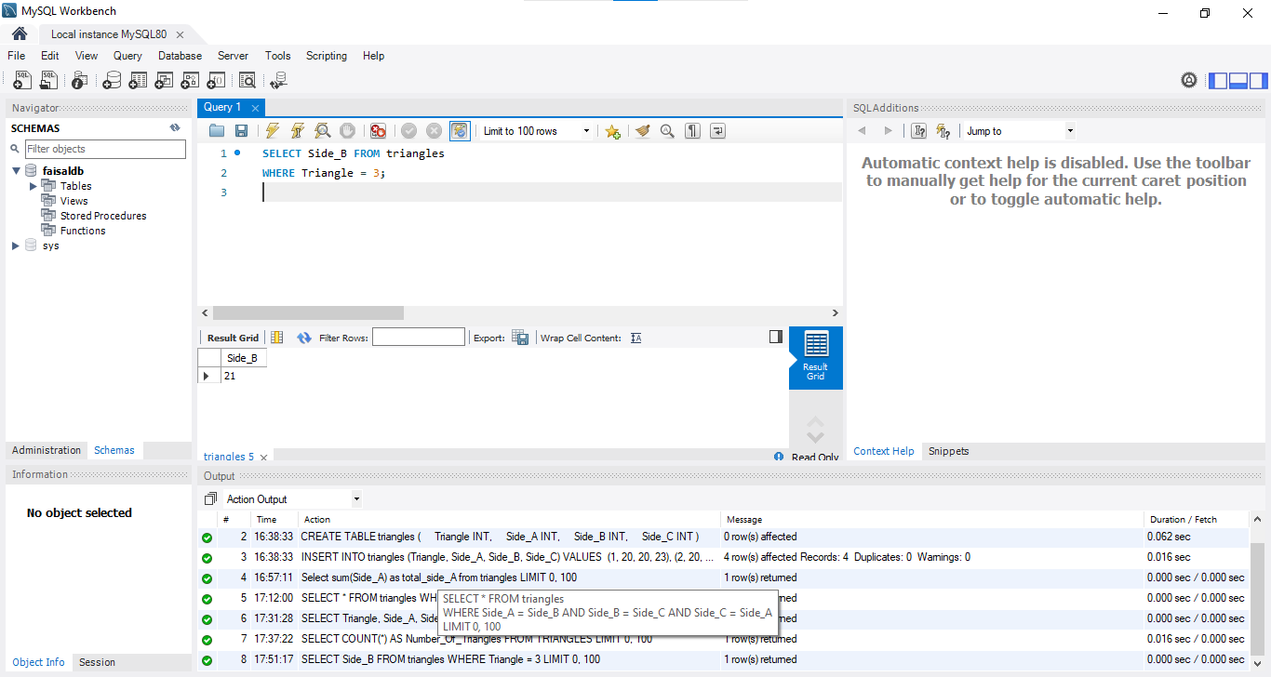

1. **Employees Data** The **Employees** table is described as follows :

|  |  |  |  |
| --- | --- | --- | --- |
| **Employee_id** | **Name** | **Months** | **Salary** |
| 12228 | Rahul | 15 | 10000 |
| 33645 | Amit | 1 | 15000 |
| 45692 | Aditi | 17 | 18000 |
| 56188 | Pavan | 11 | 21000 |

**Questions :**

1. Write a query to create the **Employees** table.

(Note:- In answer, submit all the table creation queries.)

**ANS :**

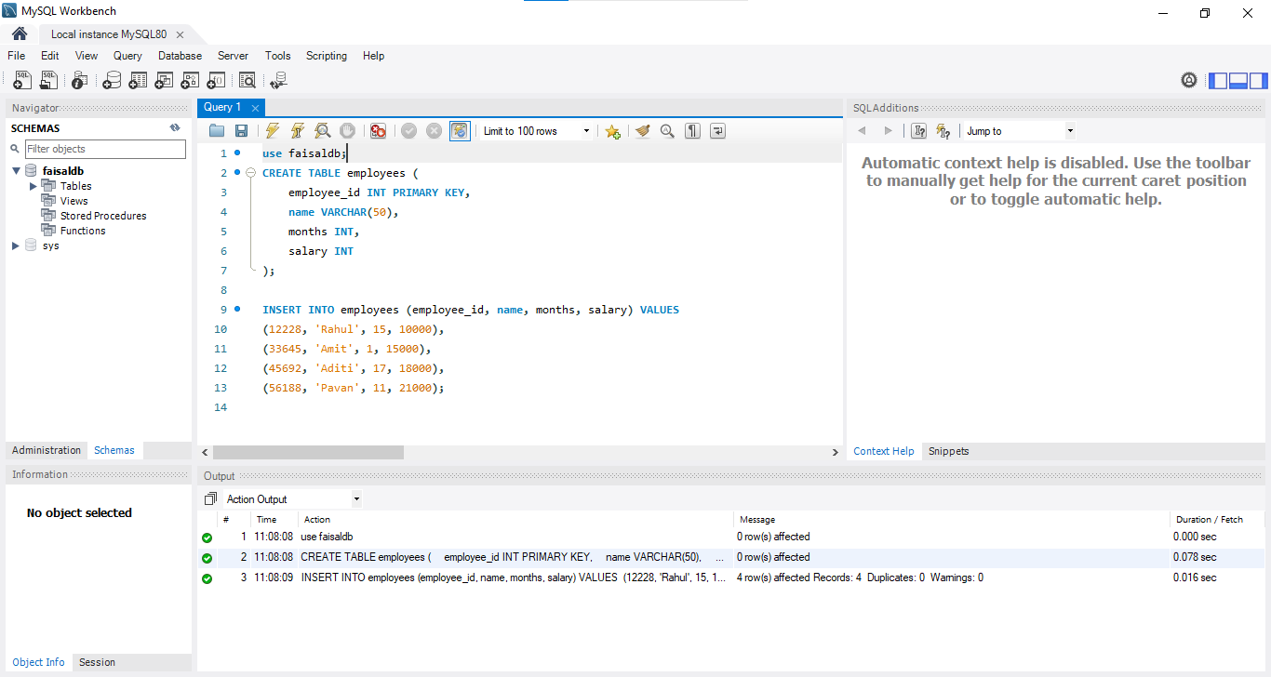

1. Write queries to get output as per required :
   * + 1. Count the total no. of employees.

**ANS :**

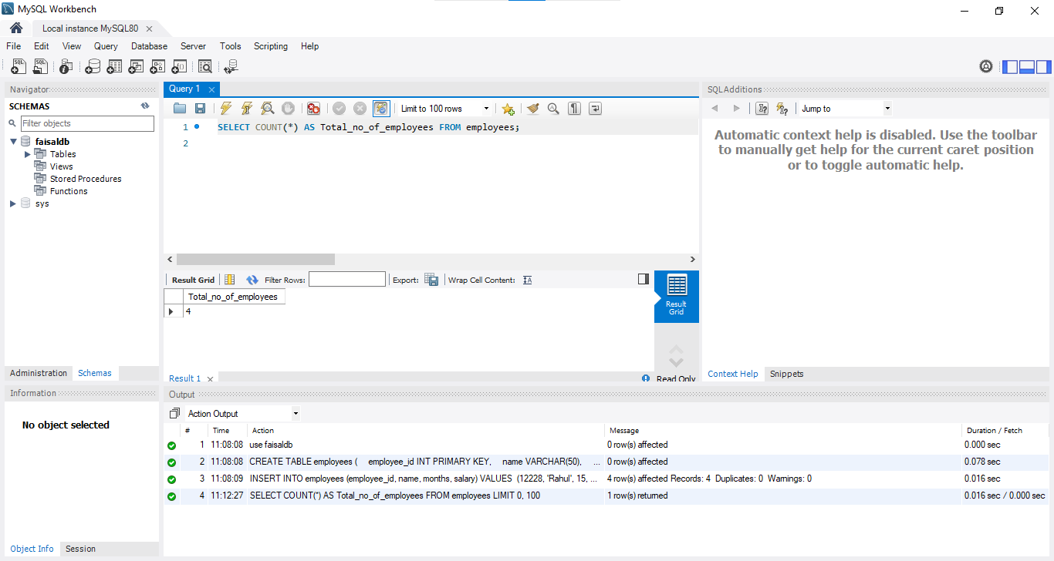

* + - 1. Find the salary of Rahul.

**ANS :**

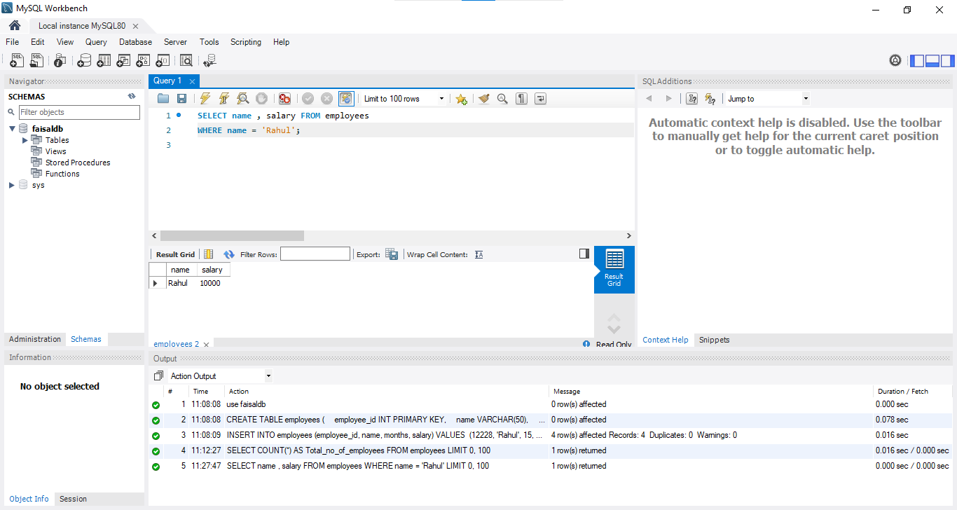

* + - 1. Set Amit’s months to 12.

**ANS :**

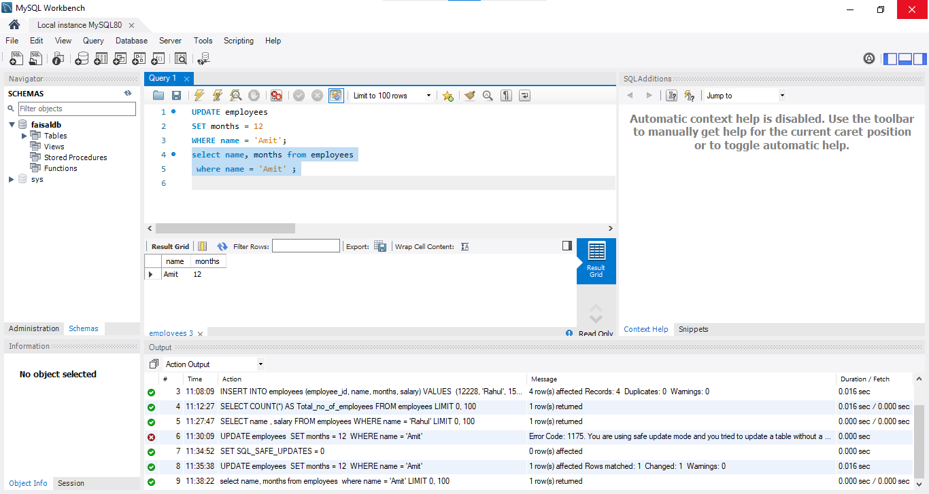

* + - 1. Find the sum of salaries of all employees.

**ANS :**

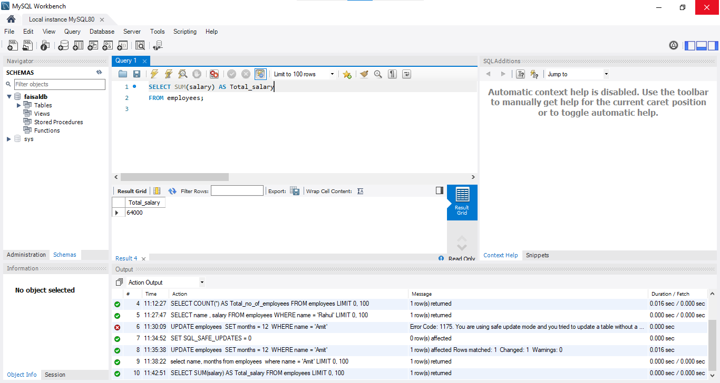

* + - 1. Find no. of employees whose name starts with ‘A’.

**ANS :**

